CENTRELINE TEA BROKERS LIMITED MOMBASA



THE KENYA CROP AND WEATHER WEEK UPTO 23RD SEPTEMBER 2025

EAST OF RIFT

KIAMBU/MURANGA/NYERI/MERU/KIRINYAGA
Rainfall was recorded over some parts of this region.
Morning rains were recorded over few places occasionally spreading to several places. Afternoon and night showers and thunderstorms were experienced over few places.
Both daytime (maximum) temperatures and night-time (minimum) temperatures increased over most stations.

Crop harvest decreased.

WEST OF RIFT

NANDI/KERICHO/BOMET/KAKAMEGA/KISII
Most parts of the Highlands West of the Rift valley and Lake Victoria Basin received rainfall.
Morning rains were recorded in several places. Afternoon and night showers and thunderstorms were experienced over several places. Some parts of this region recorded hailstorms.
Both daytime (maximum) temperatures and night-time (minimum) temperatures increased over most stations.
Crop harvest declined.
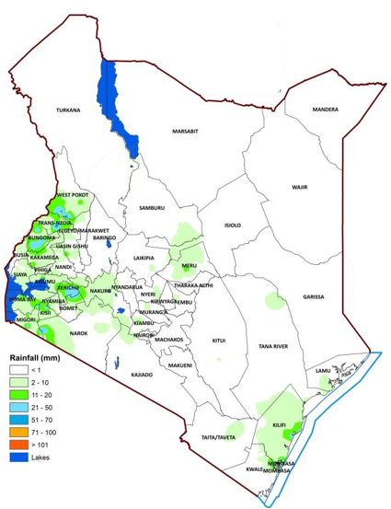 23rd September 2025

